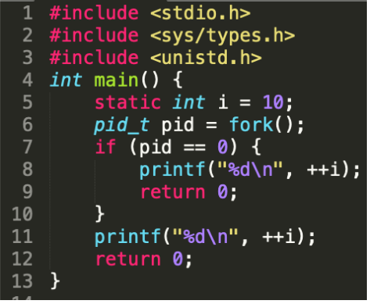

What would be the output of the following code snippet?

1. 11 11

A terminated process that has not yet been reaped is called a

* Zombie.
* Living Corpse
* **defunct process** is a **process** that has completed execution (via the exit system call) but still has an entry in the **process**table: it is a **process** in the "Terminated state".

If the parent process terminates without reaping its zombie children, then the kernel arranges for the _______ process to reap them.

* init
* Init typically will start multiple instances of "getty" which waits for console logins which spawn one's user shell process. Upon shutdown, init controls the sequence and processes for shutdown. The init process is never shut down. It is a user process and not a kernel system process although it does run as root

Which of the following function is used to suspend the current process until one of its children terminates?

1. wait(int *child_status);

Which of the following macros are used to check the exit status of the reaped child?

* WEXITSTATUS
* WIFEXITED

Which of the following macro do return true if the child terminated normally, via a call to exit

1. WIFEXITED

Which of the following macro, do returns the exit status of a normally terminated child. This status is only defined if WIFEXITED returned true

1. WEXITSTATUS

Which of the following macro, Returns true if the child that caused the return is currently stopped.

1. WIFSTOPPED